Website Booking and Reservation System for JomerVentures

A Capstone Project Proposal

Presented to the Faculty of the

Information and Communications Technology Program

STI College Global City

In Partial Fulfilment

of the Requirements for the Degree

Bachelor of Science in Information Technology

Delfin, Mary Cindy

Gesilva, Obadiah Vaughn

Lalaguna, Zyrell N.

Sanico, Mark Laurence

<Date of Proposal Defense>

# EXECUTIVE SUMMARY

# 

# APPROVAL SHEET

This capstone project proposal titled: Website Booking and Reservation System for JomerVentures prepared and submitted by Delfin Mary Cindy, Gesilva Obadiah Vaughn, Lalaguna Zyrell N., and Sanico Mark Laurence, in partial fulfillment of the requirements for the degree of Bachelor of Science in Information Technology, has been examined and is recommended for acceptance and approval.

Dexter Oseña

Capstone Project Adviser

Accepted and approved by the Capstone Project Review Panel

in partial fulfillment of the requirements for the degree of

Bachelor of Science in Information Technology

| <Panelists' Given Name MI. Family Name> | <Panelists' Given Name MI. Family Name> |
| --- | --- |
| Panel Member | Panel Member |

<Panelists' Given Name MI. Family Name>

Lead Panelist

Noted:

| <Capstone Project Coordinator's Given Name MI. Family Name> | <Program Head's Given Name MI. Family Name> |
| --- | --- |
| Capstone Project Coordinator | Program Head |

<Date of Proposal Defense>

# ACKNOWLEDGEMENT

# TABLE OF CONTENTS

|  | | **Page** |
| --- | --- | --- |
| **Title Page** | | **i** |
| **Executive Summary** | | **ii** |
| **Approval Sheet** | | **iii** |
| **Acknowledgment** | | **iv** |
| **Table of Contents** | | **v** |
| **List of Figures** | | **vi** |
| **List of Tables** | | **vii** |
| **List of Notations** | | **viii** |
| **Introduction** | | **1** |
|  | **Project Context** |  |
|  | **Purpose and Description of the Project** |  |
|  | **Objectives of the Study** |  |
|  | **Scope and Limitations of the Study** |  |
| **Review of Related Literature/Systems** | |  |
|  | **Review of Related Literature** |  |
|  | **Related Studies and/or Systems**  **Synthesis** |  |
| **Technical Background** | |  |
|  | **Overview of Current Technologies to be Used in the System** |  |
|  | **Calendar of Activities** |  |
|  | **Resources** |  |
| **Appendix** | |  |
|  | **References** |  |
|  | **Resource Persons** |  |
|  | **Personal Technical Vitae (one page per member)** |  |
|  | |  |

# LIST OF FIGURES

# LIST OF TABLES

# LIST OF NOTATIONS

# INTRODUCTION

## Project Context

Technology has played an important role in the hospitality and tourism industry over the last decades, it has helped reduce costs, enhance operational efficiency, and improve services and customer experience. It also helped tourism and hospitality industries replace expensive human labor with technological labor. Not only does it help reduce costs but it also helps avoid customer service issues (Dirden, D. 2018). JomerVentures is a travel agency where the owner has been organizing and promoting his travel and tour packages through Facebook since 2017. Founded by Mr. Jomer Dela Ombria Agong, the business is managed by him alone. The travel agency caters to customers from different locations nearby Manila. The travel agency is offering travel and tour packages to people who love to travel and want to go to different places within the Philippines either with different groups of people or exclusively. Most of his customers are joiners of the package tour offer and he also has frequent customers or suki who loved his organized package tour.

JomerVentures is using Facebook for customers to reserve and book their slot for their travel through Facebook messaging or text messaging. The page typically replies within a few hours. JomerVentures doesn’t have a website for the customers to automatically book or reserve their travel, unlike the other travel agencies where you can book or reserve your slot online. The booking or reservation of travel and tour packages are through messaging only. It does not have many alternative payment methods online like paying by credit card, or Paypal. Payments are made through bank transfer, gcash, or by cash basis.

Though traveling is not for everyone. One of the great benefits to traveling is the connections that are built, and the relationships made during one’s stay. As humanity is so often divided, learning to communicate across nations and foster a global understanding of each other is crucial to the success of all countries and people. Traveling fosters a medium to build human connections with one another by learning about culture, food, new sites, music, and the way people live their day to day lives in different parts of the world. It’s the best on-site learning a person can get. Traveling is also important for human happiness and mental health (Dispatch, 2018).

JomerVentures being a small and Medium Enterprises (SME) needs to cope up with the technology like other travel agencies. To be able to reach more customers, a website with a list of their different travel and tour packages within the Philippines and can be booked conveniently with just on the customers fingertips must be developed. On this website, customers can book or reserve their slot conveniently and be able to pay using different payment methods. Asking frequently asked questions (FAQ’s) will be answered automatically by the help of a dedicated page. A bot will also be programmed to respond to customer’s questions if they cannot find their answer on the FAQ page. With this, more customers will have access to a more convenient booking or reservation without the need of having a long conversation with the organizer.

Purpose and Description of the Project

The purpose of this project is to create a website booking and reservation system for JomerVentures wherein all travel and tour packages will be posted and be able to book and reserve conveniently. From the list of posted packages, customers can choose which place they would like to go and book and pay with different payment schemes or reserve the location.  
  
The system will have a 24 hours cancellation upon reservation in case the customer has changed their plan. The system will display all the tour packages and its information such as the inclusions of the tour, how much it cost and travel time.

## Objectives of the Study

This study aims to develop and design a website booking and reservation system for JomerVentures where customers can easily select and book their travel, have their FAQ’s and concerns answered right away, and be able to pay in different payment schemes.

* To develop a website where customers can view the list of travel and tour packages and be able to reserve and book online.
* To create a bot that will automatically answer the potential or current customers FAQs and other concerns.
* To create an online payment system for customers who prefer to use Debit/Credit Cards, Paypal, Gcash, Coins.ph.

## Scope and Limitations of the Study

In developing the system, the following scope must be in the application. The system will have a homepage wherein customers can view the different client modules. It has a register and login form for new and existing customers, upon registration a user must agree to the terms and conditions of JomerVentures. On the homepage, the customers can see pictures of previous tours of JomerVentures and what the client says about the agency as well as sending inquiries or asking questions through the help of a bot. The About Us module contains information about the travel agency that the customer should know. The Tours module contains travel and tour package offers of different places that can be reserved or booked by the customer. On the My Booking module, the user can view and manage the booking or reservation they have made, as well as seeing the history of their travel. On the profile modules, the customer can edit their profile information and log out from using the website. On the contact module, the user will be able to send an inquiry to the travel agency from different contact information provided. Upon booking or reservation, there will be a payment module where they can opt to pay via debit/credit cards, Gcash, Paypal, or coins.ph. The customer will be able to cancel their bookings 24 hours before the time of departure for free. If canceled less than 24 hours before departure, a cancellation fee will be charged.

The system does not have an offline feature. The system does not have an applicatication that can be downloaded in the apps store.

# review of related literature/systems

Dirden, D. (2018). “How Information Technology Has Affected the Tourism and Hospitality Industry.” Over the last decade, information technology has played a significant role in the hospitality and tourism industries. Technology has assisted in lowering costs, increasing operational efficiency, and improving services and customer satisfaction. Both customers and businesses can benefit from improved communication, reservations, and guest service systems. Tourism and hospitality businesses have benefited from electronic labor to replace pricey human labor. Computer systems facilitate communication between large hotel chains in multiple locations. It also places staff on the same page, providing easy access to information and significantly improving the guest experience. Guest inquiries, housekeeping information and bookings are all integrated into one system. This not only saves money on labor, but it also helps to avoid customer service concerns. The Internet has a great impact on hospitality and tourism. The first experience of your business customers is when they visit your website. This includes viewing photos and reviews from previous guests. It's important for businesses to effectively use online advertising, social media, blogs, and online shopping to improve customer convenience, especially if their competitors are doing the same. Mobile tablets and smartphones have replaced large desktop computers and have virtually disappeared. This is useful as many travelers carry some kind of mobile device while traveling. This helps hospitality businesses notify customers of reservation changes and delays, offer offers, and promote using GPS tracking. The use of technology in the hospitality and tourism industry has helped speed up operations and make the travel process much more enjoyable and efficient. Technology can be useful not only for large hotel chains, but also for B & Bs and other small businesses in the industry.

According to Dispatch (2018). “Travelling is important for mental growth and human happiness”. Travel is important to humans. We are all creatures of the same kind of community, but our place determines social behavior under the laws of civilization and government. We are very similar, but our little world is still very completely different. Traveling to see places outside our hometown is important to our exposure to the world. Whether you are traveling domestically or abroad, it will be an experience you will never forget. Traveling abroad may require additional planning. B. Apply for a visa. Even if you don't have a Schengen visa reservation at the last minute, you still need to contact where you can get one. Even if you are on a business trip to another state, your trip will be happy. It is important to maintain a continuous pattern of learning and consciousness throughout life, and travel is a great way to do so. Travel brings us into contact with other cultures. If a person spends his life in his hometown, it will be difficult to fully understand the struggles and celebrations of other regions and countries. Countries can vary widely from country to country. Dialects are different, food, local music and terrain vary from place to place. There are different languages ​​and communication channels around the world. When we touch on these things, we can openly understand that it is our similarities as people that connect us, even if we are different. Travel is wonderful for humankind in the world. Without a doubt, one of the best things about visiting a new place is food. Many television shows aim to introduce you to everything about other cultures and the food they eat. Food shows many virtues and explains a lot about culture, from local agriculture to the imports needed. Food is traditional, historic and evolving and is what everyone needs. Eating out is a great way to learn about different dishes to incorporate other places. It's a great way to share a culture. One of the great benefits to traveling is the connections that are built, and the relationships made during one’s stay. As humanity is so often divided, learning to communicate across nations and foster a global understanding of each other is crucial to the success of all countries and people. Traveling fosters a medium to build human connections with one another by learning about culture, food, new sites, music, and the way people live their day to day lives in different parts of the world. It’s the best on-site learning a person can get. The internet can only explain so much about a place. Even with virtual reality being a new and innovative option to take tours of places, there is still nothing like seeing a new place in person for the first time. Travel is also important for human well-being and mental health. Studies show that travel can be good for your mental health. People live in a world that constantly copes with the stress of work and relationships and supports their families, so it's time for them to get rid of all that stress so that they can continue to function properly. It is important to apply. Travel helps people better understand themselves and create a sense of unity in their personality. This is important. Because when our brain becomes saturated with stressful things and our heads are full of anxious thoughts, it can be very difficult to stay present. Travel gives an individual a moment of existence, even if it is only for a short time. Travel can also make people happy overall. The power of happiness probably means life. Finding love and happiness is what most people crave. Travel is also a way to build mental resilience. Visiting new places can be very scary, especially if you have to overcome language and cultural barriers. Learning emotional regulation and intelligence in these situations can help build stronger mental health. Travel is a collection of many experiences. It's a way to learn and grow within yourself and grow with others by learning something new. This is a way to improve your organization and time management skills. Travel is an opportunity to communicate with someone other than ourselves or people in our area. Through communication and understanding, travel can provide a way to connect humanity.

Stroller G. (2019). “39 Million Americans Can’t Afford A Vacation This Summer.” Thirty-nine million Americans, about 15% of the adult population, will not be able to afford this summer vacation, a new poll released Thursday shows. According to a March 2022 online survey of 2,577 adults on Bankrate.com by YouGovPlc. Bankrate.com states that the results represent all adults in the United States over the age of 18. Many Americans are unable to take vacation, but less than last year. According to a Bankrate.com survey last year, 24% of adults in the United States did not plan for summer vacation because they could not afford it. Ted Rossman, an industry analyst at Bankrate.com, said: This year's survey unearths that, amongst individuals who are making plans for a summer time holiday, the common anticipated cost is $1,979. Older millennials (a long time 30-38) anticipate to spend $2,366 — $1,069 extra than more youthful millennials (a long time 23-29). Adults dwelling withinside the West anticipate to spend $2,265 — $657 extra than adults withinside the Midwest. The survey additionally unearths that 38% of adults who receive a commission day off agree that they may use all their holiday days this year. Thirty-5 percent assume they`ll use no extra than 1/2 of their allocated day off. “I think 35% of US adults who take paid leave but don't plan to take more than half of it make a big mistake,” says Rothman. "I understand that if my employer permits, a little vacation will be carried over to next year, but it's a mistake to leave more than half of my vacation time on the table. I've earned this time, so take a break and recharge. It's important. " If you want to take a summer vacation but feel you can't afford it, you should consider signing up for a travel or cash back credit card. "We still have time to convert sign-up bonuses and recurring expense rewards into free or discounted trips," he says. "Please pay the full invoice to avoid interest." Rothman's preferred credit cards for earning rewards include Chase Sapphire Aprifard, Capital One Saver and Wells Fargo Propel American Express Card. I have. They offer sign-up bonuses ranging from $ 300 to $ 750 and "favorable ongoing rewards," he says. The Staycation (villa or nearby) is a good option if traveling away from home is not affordable. Rothman states that such vacations are "most effective." Not only can you do the laundry and get things done, but you can also unplug, visit cheap tourist attractions nearby, and have fun with family and friends. "

H. Purnomo (2019). “The COVID-19 epidemic initially affected China, which was the world's first airline market to be severely impacted.” As the epidemic has been mostly limited domestically, it has been steadily recovering. However, as a result of the worldwide pandemic's expansion and the resulting uncertainty, airline passengers' travel behavior has changed dramatically. This study gathered data on flight passengers from Travel Sky in the Chinese market. This article investigates changes in airline passenger travel behavior, such as ticket booking time, passenger age distribution, refunds and ticket adjustments, and passenger arrival time at airports, in addition to aggregate passenger flow patterns. This is one of the first studies to use objective passenger-level data to look at micro-level changes in airline passenger travel behavior. Psychological alterations brought on by the epidemic in air travelers are investigated, with managerial and policy implications for the pandemic's normalization and recovery of the airline business in the post-pandemic era.

Timmy H. Tseng, Yi-Shun W, Yung-Chien Tsai (2021), Based on past information/e-commerce system success models and a hospitality website quality rating model, this study provides a model for selecting amongst third-party booking systems from a customer perspective. The analytic hierarchy process approach is used to identify factors that influence customers' choice of third-party booking systems, as well as the relative relevance of each factor. Expert Choice software is used to evaluate data obtained from two waves of online surveys. The findings show that the following elements are prioritized: security, information quality, service quality, system quality, and marketing. The findings of this study are compared to those of other investigations, and the similarities and differences are explored. A practitioner guide on how to create a successful third-party booking system is offered based on the outcomes of the analytic hierarchy approach. The advanced model differs previous hotel selection models in that it demonstrates a higher level of theoretical completeness.

Sta. Ana, K. K. S., Tolentino, K. C. R., Borromeo, K. G., & Mercado, J. M. T. (2020). Status of hearing-impaired tour guides of Angeles city, Pampanga, Philippines: a basis for a proposed intervention program. Revista Turismo & Desenvolvimento, (33), 9-28.Angeles City, Pampanga established the first ever accredited and certified hearing-impaired tour guides in the Philippines. A qualitative method research was developed to propose an intervention program for the hearing-impaired tour guides through assessment of the current status of the hearing-impaired tour guides and efforts of stakeholders. Different frameworks were used to identify the effectiveness of the training, communication and interpretation skills of hearing-impaired tour guides by conducting review of different documents, in-depth interview and focus group discussion. There is an effective training program given to the participants, but problems emerge especially on the sustainability and the long-term programs for the hearing-impaired tour guides.

REVIEW RELATED SYSTEMS

Jooyoung Hwang, Sangwon Park & Mina Woo (2018). “Understanding user experiences of online travel review websites for hotel booking behaviours: an investigation of a dual motivation theory, Asia Pacific Journal of Tourism Research.” Online travel review sites (a type of social media) have become an important source of information for online travelers. However, previous research has focused primarily on the issue of social media site recruitment. This paper aims to recognize the theoretical gaps in the tourism industry, understand the user experience of using social media related to user satisfaction, and determine the success of information systems. The results of this study show that, according to motivational theory, both extrinsic (ie, the quality of inference in consumer reviews) and intrinsic (ie, the reliability of sources) motivate users. It shows that it plays an important role in enhancing. In particular, the integrity, relevance, flexibility, timeliness, and reliability of sources of discussion have a positive impact on user satisfaction, reusing websites for tourism products. It leads to the intention to purchase. It also discusses the practical implications for online tourism marketers.

Kijung Choi, Ying Wang & Beverley Sparks (2019). “Travel app users’ continued use intentions: it’s a matter of value and trust, Journal of Travel & Tourism Marketing, 36:1, 131-143.” This study looks at factors that influence the ongoing intent to use mobile apps for travel-related purposes. Interviews with 22 people provided data to develop a conceptual model of intent to continue using the travel app. This model utilizes an expectation confirmation model framework and interviews to show the relationship between functional value, pleasure value, satisfaction, and trust, in terms of friendliness, travel objectives, travel app types, and technology proficiency. Discuss the relationship between moderators. Predictor for continued use. The results of the survey generate a deeper understanding of the continued use of travel apps.

The study of Aguilar, M. G. W. ., Limpot, R. A. ., & Macasinag, P. H. . (2020). “The Tourism Business Industry of the Municipality of Tanay, Rizal, Philippines”: An Assessment on Human Resource and a Province-Wide Market Research. Journal of Tourism Management Research, *7*(1), 52–67. Evaluated the tourism industry in Rizal's city of Tanai as a new tourist destination with a focus on tourism product marketability, talent expertise and local government tourism development initiatives. The results show that the success of Paraya Nature Farm could make the community a hub for state agritourism. The state is recognized as the main market for affordable boutique hotels offering resort-like facilities. It was also pointed out that the market prefers tourism, where restaurants, tourist destinations and hotels are located in commercial areas close to each other. The people of the state are adventurous and love nature-oriented destinations, but when it comes to dining, casual Korean and Filipino food are preferred. Travel agencies can also thrive in the state as the market prefers to seek travel support over travel preparation. Given the importance of human resources to the success of the industry as a leading provider of services, Rizal's Tanai community has demonstrated a high degree of expertise in the industry, resulting in intensive training and education. Turned out to be necessary and will be bad.

## Synthesis

The purpose of this literature is about how technology is designed to help the process work quickly and properly to its objective. Lowering expenses, enhancing operational efficiency, providing customers needs and wants and improving services and customer happiness have all been aided by technology. Improved communication, reservation, and guest service systems help both customers and companies. Electronic labor has helped tourism and hospitality firms save money by replacing expensive human labor. Large hotel chains with several sites can communicate through computer systems. It also brings personnel on the same page, making information more accessible and improving the visitor experience. All guest queries, housekeeping information, and reservations are handled through one system.The Internet has had a significant influence on the hotel and tourist industries. Customers' first impression of your company is when they visit your website. This includes looking at past guests' images and feedback. Businesses must efficiently use online advertising, social media, blogs, and online shopping to promote consumer convenience, especially if they sell products online. Competitors are following suit. Mobile tablets and smartphones have almost completely supplanted huge desktop PCs. This is advantageous because many passengers travel with a mobile device. This assists hospitality firms in informing their consumers. Notify customers of reservation changes and delays, make special discounts, and encourage the use of GPS tracking. Technology has aided the hospitality and tourism industries in speeding up processes and making the travel journey more fun and efficient. Large hotel companies aren't the only ones that can benefit from technology. B&Bs and other small enterprises in the industry are also included.

“Travelling is important for mental growth and human happiness”. Travel is important to humans. Traveling to see places outside our hometown is important to our exposure to the world. It is important to maintain a continuous pattern of learning and consciousness throughout life, and travel is a great way to do so. Dialects are different, food, local music and terrain vary from place to place. There are different languages ​​and communication channels around the world. When we touch on these things, we can openly understand that it is our similarities as people that connect us, even if we are different. Without a doubt, one of the best things about visiting a new place is food. Food shows many virtues and explains a lot about culture, from local agriculture to the imports needed. Eating out is a great way to learn about different dishes to incorporate other places. It's a great way to share a culture. As humanity is so often divided, learning to communicate across nations and foster a global understanding of each other is crucial to the success of all countries and people. Traveling fosters a medium to build human connections with one another by learning about culture, food, new sites, music, and the way people live their day to day lives in different parts of the world. Travel is also important for human well-being and mental health. Travel helps people better understand themselves and create a sense of unity in their personality. Travel can also make people happy overall. Travel is also a way to build mental resilience. Visiting new places can be very scary, especially if you have to overcome language and cultural barriers. Travel is an opportunity to communicate with someone other than ourselves or people in our area. Through communication and understanding, travel can provide a way to connect humanity.

This study claims that many Americans can't take vacation, but less than last year. According to a Bankrate. com survey last year, 24% of the 4,444 adults in the United States did not plan for summer vacation because they could not afford it. Ted Rossman, an industry analyst at Bankrate.com, said: According to this year's survey, the usual estimated cost is $ 1,979 among those planning a summer vacation. Adults living in the West expect to pay $ 2,265- $ 657 more than adults in the Midwest. According to a survey, 38% of adults who take commission-based leave agree that they can take all their leave this year. 35% of US adults who take paid leave but don't plan to take more than half of it are making big mistakes,” says Rothman, that some of my vacation will be carried over to next year if my employer allows it, but it's a mistake to leave more than half of my vacation on the table. "If you want to take a summer vacation but can't afford it, consider signing up for a travel or cash back credit card," he says. "Pay full to avoid interest. '' Rothman's preferred credit cards to earn rewards are that they offer sign-up bonuses ranging from $ 300 to $ 750 and "cheap continuous rewards," he says.

A previous success model of information / e-commerce systems and a quality evaluation model of hospitality websites, this survey is from the customer's perspective. Analytic hierarchy process is used to identify the factors that influence a customer's choice of third-party booking system and the relative importance of each factor. Expert Choice software is used to evaluate the data obtained from the two waves of online surveys. The results show that security, information quality, quality of service, system quality, and marketing factors are prioritized. The results of this study will be compared to the results of other studies to clarify similarities and differences. Based on the results of the analysis hierarchy approach, it provides a working guide for creating a successful third-party booking system. The advanced model differs from the previous hotel selection model in that it has a high level of theoretical integrity.

"Understanding the User Experience of Online Travel Review Websites on Hotel Booking Behavior: Asia Pacific Journal of Tourism Research." by Jooyoung Hwang, Sangwon Park & Mina Woo (2018). Online travel review sites (a type of social media) are an important source of information for online travelers. It has become. However, previous surveys have focused primarily on recruiting social media sites. This white paper aims to identify theoretical gaps in the tourism industry, understand the user experience of using social media in terms of user satisfaction, and determine the success of the information system. The results of this study show that, according to motivational theory, both extrinsic (ie, quality of conclusions in consumer reviews) and intrinsic (ie, source reliability) motivate users. increase. It shows that it plays an important role in improvement. In particular, the integrity, relevance, flexibility, timeliness, and reliability of discussion sources have a positive impact on user satisfaction by reusing tourism product websites. It leads to the purchase intention. It also discusses the practical implications for online tourism marketers.

This study claims that a previous success model of information / e-commerce systems and a quality rating model of hospitality websites, this survey is for choosing from third-party booking systems. Provide a model. Customer perspective. The analytic hierarchy process approach is used to identify the factors that influence a customer's choice of third-party booking system, and the relative importance of each factor. Expert Choice software is used to evaluate the data obtained from the two waves of online surveys. The results show that security, information quality, quality of service, system quality, and marketing factors are prioritized. The results of this study will be compared to the results of other studies to clarify similarities and differences. Based on the results of the analysis hierarchy approach, it provides a working guide for creating a successful third-party booking system. The advanced model differs from the previous hotel selection model in that it has a high level of theoretical integrity.

Situation of Hearing Impaired Tour Guides in Angeles, Pampanga, Philippines: The basis of the proposed intervention program. The City of Angeles, Pampanga, established the first certified and certified tour guide for the hearing impaired in the Philippines. We used different frameworks, different documents, detailed interviews, and focus group discussions to determine the effectiveness of training, communication, and interpreting skills for hearing-impaired tour guides. There are effective training programs for participants, but problems arise with sustainability and long-term programs, especially for hearing-impaired tour guides.

“The Tourism Business Industry of the Municipality of Tanay, Rizal, Philippines”: An Assessment on Human Resource and a Province-Wide Market Research. Evaluated the tourism industry in Rizal`s city of Tanai as a new tourist destination with a focus on tourism product marketability, talent expertise and local government tourism development initiatives. It was also pointed out that the market prefers tourism, where restaurants, tourist destinations and hotels are located in commercial areas close to each other. The people of the state are adventurous and love nature-oriented destinations, but when it comes to dining, casual Korean and Filipino food are preferred. Given the importance of human resources to the success of the industry as a leading provider of services, Rizal's Tanai community has demonstrated a high degree of expertise in the industry, resulting in intensive training and education.

Register Page and Homepage of JomerVentures

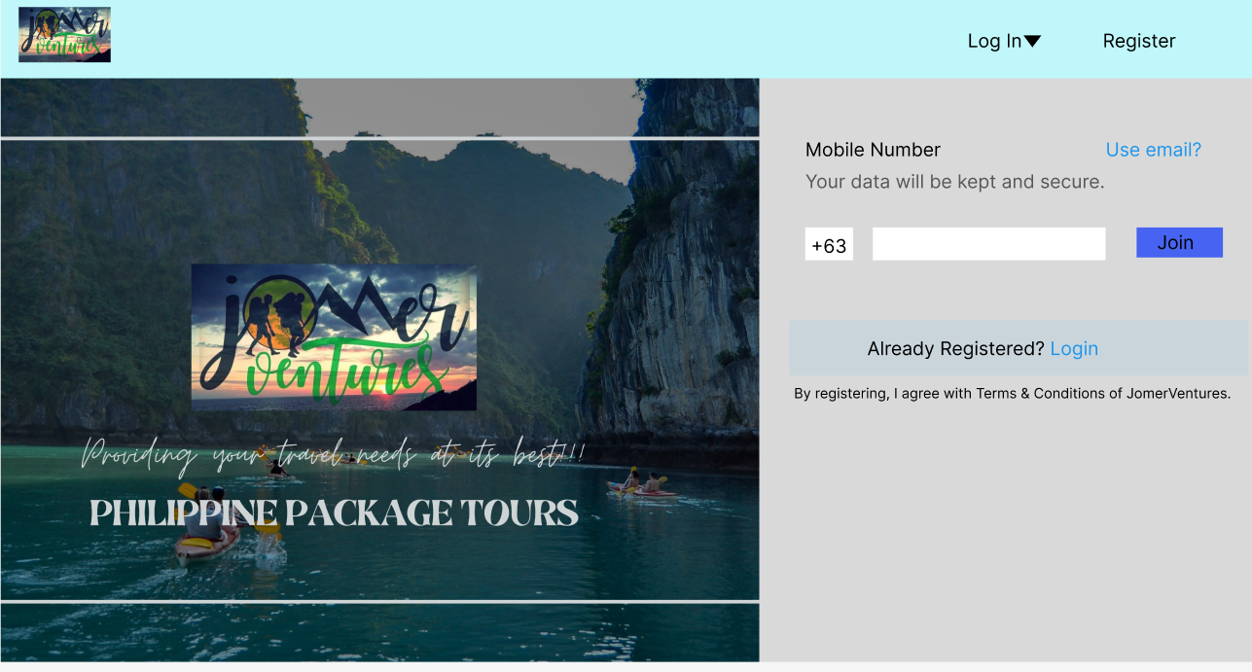

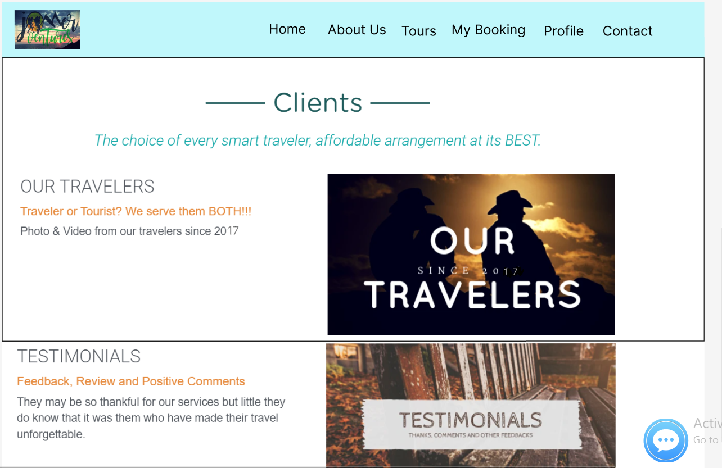z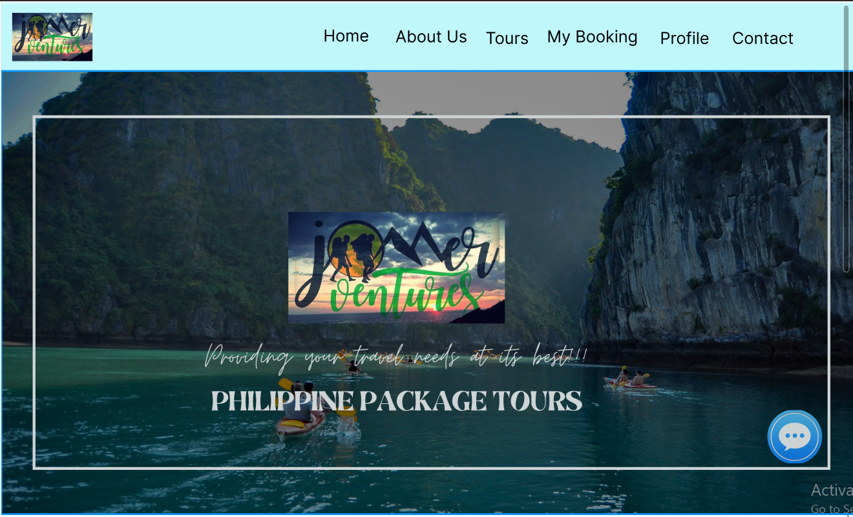

## TECHNICAL BACKGROUND

## Overview of Current Technologies to be Used in the System

In the development process of the system, the developers made use of various technologies to be able to complete the project. The Integrated Development Environment or IDE that the developers used to edit, debug and build codes for the website application was Visual Studio.   
C# was the programming language that was used to code the back end function of the website and to be able to connect it to the database.   
HTML/CSS/BOOTSTRAP was used to design the front end of the website which is the layout and the user interface for its intended users.   
For the DBMS, MySQL was used to create the database and tables for customers’ profiles, website monitoring and recording.   
.NET Framework was used to make the design of the UI as well as the Back side of the website/ functions. The developers used ASP.NET framework for the website because it provides simplicity to perform common tasks and easier to deploy and configure. ASP.NET framework is easier to implement. Applications that were developed using ASP.NET are accessible on a global basis leading to efficient information management. ASP.NET gives us full control on our development and can be used on any projects.

Methodology:

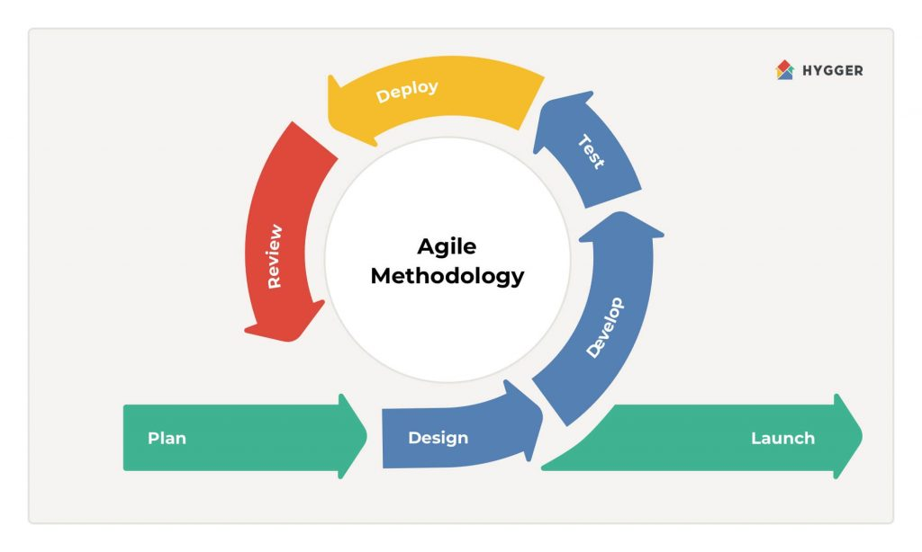

*Figure 3: Agile Methodology*

The developers use Agile Methodology in the development because it saves time and resources. The whole process was broken down into phases and is more efficient to use because several tasks are being done simultaneously. Regular meetings were conducted within the team to plan the course of actions and track the progress. Issues are easily addressed as well. Deliverables were targeted to be completed within the timeline.

## 

## Hardware and Software Requirements To be able to run the web application, the device should meet the following minimum and recommended requirements.

| Minimum Requirements | Recommended Requirements: |
| --- | --- |
| - Any browser (e.g, Chrome, Firefox)  -Operating System: Windows 8  -Processor: 1.9 GHZ x86 - or x64-bit processor or better. It should run on any CPU (AMD, Intel, etc)  -Memory: 2 GB RAM  -Display: Super VGA with resolution of 1024 x 768 | - Any browser (e.g, Chrome, Firefox)  -Operating System: Windows 8 or later  -Processor: 1.9 GHZ x86 - or x64-bit processor or better. It should run on any CPU (AMD, Intel, etc)  -Memory: 4GB+ RAM  - Display: 1280x1024 or larger |

## 

CALENDAR OF ACTIVITIES

**Gantt Chart of Activities**

| MONTH | FEBRUARY | | | | MARCH | | | | APRIL | | | | MAY | | | | JUNE | | | | JULY | | | | AUGUST | | | | SEPTEMBER | | | | OCTOBER | | | | NOVEMBER | | | |
| --- | --- | --- | --- | --- | --- | --- | --- | --- | --- | --- | --- | --- | --- | --- | --- | --- | --- | --- | --- | --- | --- | --- | --- | --- | --- | --- | --- | --- | --- | --- | --- | --- | --- | --- | --- | --- | --- | --- | --- | --- |
| ACTIVITY |
| Title Proposal |  |  |  |  |  |  |  |  |  |  |  |  |  |  |  |  |  |  |  |  |  |  |  |  |  |  |  |  |  |  |  |  |  |  |  |  |  |  |  |  |
| Project Context |  |  |  |  |  |  |  |  |  |  |  |  |  |  |  |  |  |  |  |  |  |  |  |  |  |  |  |  |  |  |  |  |  |  |  |  |  |  |  |  |
| Project Description |  |  |  |  |  |  |  |  |  |  |  |  |  |  |  |  |  |  |  |  |  |  |  |  |  |  |  |  |  |  |  |  |  |  |  |  |  |  |  |  |
| Objectives of the Study |  |  |  |  |  |  |  |  |  |  |  |  |  |  |  |  |  |  |  |  |  |  |  |  |  |  |  |  |  |  |  |  |  |  |  |  |  |  |  |  |
| Scope and Limitations |  |  |  |  |  |  |  |  |  |  |  |  |  |  |  |  |  |  |  |  |  |  |  |  |  |  |  |  |  |  |  |  |  |  |  |  |  |  |  |  |
| RRL and RSS |  |  |  |  |  |  |  |  |  |  |  |  |  |  |  |  |  |  |  |  |  |  |  |  |  |  |  |  |  |  |  |  |  |  |  |  |  |  |  |  |
| Overview of the current technology use in the System |  |  |  |  |  |  |  |  |  |  |  |  |  |  |  |  |  |  |  |  |  |  |  |  |  |  |  |  |  |  |  |  |  |  |  |  |  |  |  |  |
| Hardware/Software Requirements |  |  |  |  |  |  |  |  |  |  |  |  |  |  |  |  |  |  |  |  |  |  |  |  |  |  |  |  |  |  |  |  |  |  |  |  |  |  |  |  |
| Methodology of the Study |  |  |  |  |  |  |  |  |  |  |  |  |  |  |  |  |  |  |  |  |  |  |  |  |  |  |  |  |  |  |  |  |  |  |  |  |  |  |  |  |
| Prototype(Design) |  |  |  |  |  |  |  |  |  |  |  |  |  |  |  |  |  |  |  |  |  |  |  |  |  |  |  |  |  |  |  |  |  |  |  |  |  |  |  |  |
| Coding |  |  |  |  |  |  |  |  |  |  |  |  |  |  |  |  |  |  |  |  |  |  |  |  |  |  |  |  |  |  |  |  |  |  |  |  |  |  |  |  |
| Implementation |  |  |  |  |  |  |  |  |  |  |  |  |  |  |  |  |  |  |  |  |  |  |  |  |  |  |  |  |  |  |  |  |  |  |  |  |  |  |  |  |
| Maintenance |  |  |  |  |  |  |  |  |  |  |  |  |  |  |  |  |  |  |  |  |  |  |  |  |  |  |  |  |  |  |  |  |  |  |  |  |  |  |  |  |
|  |  |  |  |  |  |  |  |  |  |  |  |  |  |  |  |  |  |  |  |  |  |  |  |  |  |  |  |  |  |  |  |  |  |  |  |  |  |  |  |  |
|  |  |  |  |  |  |  |  |  |  |  |  |  |  |  |  |  |  |  |  |  |  |  |  |  |  |  |  |  |  |  |  |  |  |  |  |  |  |  |  |  |
|  |  |  |  |  |  |  |  |  |  |  |  |  |  |  |  |  |  |  |  |  |  |  |  |  |  |  |  |  |  |  |  |  |  |  |  |  |  |  |  |  |
|  |  |  |  |  |  |  |  |  |  |  |  |  |  |  |  |  |  |  |  |  |  |  |  |  |  |  |  |  |  |  |  |  |  |  |  |  |  |  |  |  |
|  |  |  |  |  |  |  |  |  |  |  |  |  |  |  |  |  |  |  |  |  |  |  |  |  |  |  |  |  |  |  |  |  |  |  |  |  |  |  |  |  |
|  |  |  |  |  |  |  |  |  |  |  |  |  |  |  |  |  |  |  |  |  |  |  |  |  |  |  |  |  |  |  |  |  |  |  |  |  |  |  |  |  |

## Resources

## Hardware

The hardware used are desktop computers and laptops.

* Software

The software used in the development of the system are Visual Studio, C#, MySQL, HTML/CSS/BOOTSTRAP

## Appendix

# References

Dirden, D.(2018). *“How Information Technology Has Affected the Tourism and Hospitality Industry.”*

Dispatch (2018). *“Travelling is important for mental growth and human happiness”.*

Stoller G. (2019). “*39 Million Americans Can’t Afford A Vacation This Summer”.*

Timmy H. Tseng, Yi-Shun W, Yung-Chien Tsai (2021. *“Applying an AHP Technique for Developing A Website Model of a Third-Party Booking System”.*

Jooyoung Hwang, Sangwon Park & Mina Woo (2018). *“Understanding user experiences of online travel review websites for hotel booking behaviours: an investigation of a dual motivation theory, Asia Pacific Journal of Tourism Research.”*

H. Purnomo (2019)*. “The COVID-19 epidemic initially affected China, which was the world's first airline market to be severely impacted.”*

Kijung Choi, Ying Wang & Beverley Sparks (2019)*. “Travel app users’ continued use intentions: it’s a matter of value and trust, Journal of Travel & Tourism Marketing, 36:1, 131-143.*

Sta. Ana, K. K. S., Tolentino, K. C. R., Borromeo, K. G., & Mercado, J. M. T. (2020)*. “Status of hearing-impaired tour guides of Angeles city, Pampanga, Philippines: a basis for a proposed intervention program. Revista Turismo & Desenvolvimento”, (33), 9-28.*

Aguilar, M. G. W. ., Limpot, R. A. ., & Macasinag, P. H. . (2020). *“The Tourism Business Industry of the Municipality of Tanay, Rizal, Philippines: An Assessment on Human Resource and a Province-Wide Market Research. Journal of Tourism Management Research”. 7(1), 52–67.*

Curriculum Vitae of

Mary Cindy B. Delfin

8887 P. Victor Street, Guadalupe Nuevo, Makati City 1212

marycindydelfin@yahoo.com

09663066441

EDUCATIONAL BACKGROUND

| Level | Inclusive Dates | Name of school/ Institution |
| --- | --- | --- |
| Tertiary | 2019 - Present | STI College Global City |
| Vocational/Technical | N/A | N/A |
| High School |  | Casanayan National High School |
| Elementary |  | Casanayan Elementary School |

PROFESSIONAL OR VOLUNTEER EXPERIENCE

| Inclusive Dates | Nature of Experience/  Job Title | Name and Address of Company or Organization |
| --- | --- | --- |
|  |  |  |
| N/A | N/A | N/A |
|  |  |  |
|  |  |  |

Listed in reverse chronological order (most recent first).

AFFILIATIONS

| Inclusive Dates | Name of Organization | Position |
| --- | --- | --- |
| 2020 - 2021 | Neo Gen Sys | Coordinator |
|  |  |  |
|  |  |  |
|  |  |  |

Listed in reverse chronological order (most recent first).

SKILLS

| SKILLS | Level of Competency | Date Acquired |
| --- | --- | --- |
| Java Programming | Basic |  |
| C# Programming | Basic |  |
| MS Office | Basic |  |

SAP Basic

TRAININGS, SEMINARS, OR WORKSHOPS ATTENDED

| Inclusive Dates | Title of Training, Seminar, or Workshop |
| --- | --- |
|  |  |
| N/A | N/A |
|  |  |
|  |  |

Listed in reverse chronological order (most recent first).

ROLE IN THE DEVELOPMENT : Designer/ Documentation

Curriculum Vitae of

<ObadiahVaughn Gesilva>

<61 F. Asedillo st. Bagong Katipunan Pasig City>

<obgesilva31@gmail.com>

09271419154/0284706437

EDUCATIONAL BACKGROUND

| Level | Inclusive Dates | Name of school/ Institution |
| --- | --- | --- |
| Tertiary | 2019 - Present | STI COLLEGE GLOBAL CITY |
| Vocational/Technical |  |  |
| High School | 2013 - 2017 | RIZAL HIGH SCHOOL |
| Elementary | 2006 - 2013 | DR. SIXTO ANTONIO ELEMENTARY SCHOOL |

PROFESSIONAL OR VOLUNTEER EXPERIENCE

| Inclusive Dates | Nature of Experience/  Job Title | Name and Address of Company or Organization |
| --- | --- | --- |
|  |  |  |
|  |  |  |
|  |  |  |
|  |  |  |

Listed in reverse chronological order (most recent first).

AFFILIATIONS

| Inclusive Dates | Name of Organization | Position |
| --- | --- | --- |
| N/A | N/A | N/A |
|  |  |  |
|  |  |  |
|  |  |  |

Listed in reverse chronological order (most recent first).

SKILLS

| SKILLS | Level of Competency | Date Acquired |
| --- | --- | --- |
| Java Programming | Basic |  |
| C# Programming | Basic |  |
| MS Office | Basic |  |

SAP Basic

TRAININGS, SEMINARS, OR WORKSHOPS ATTENDED

| Inclusive Dates | Title of Training, Seminar, or Workshop |
| --- | --- |
| N/A | N/A |
|  |  |
|  |  |
|  |  |

Listed in reverse chronological order (most recent first).

Curriculum Vitae of

Zyrell N. Lalaguna

B85 L26 Daffodil St. Brgy. Rizal, Makati City

zyrell210@gmail.com

09489448691

EDUCATIONAL BACKGROUND

| Level | Inclusive Dates | Name of school/ Institution |
| --- | --- | --- |
| Tertiary | 2019-present | STI College Global City |
| Vocational/Technical | N/A |  |
| High School |  | Capitolina O Legazpi Memorial High School |
| Elementary |  | Alejandro Delos Reyes Elem. School |

PROFESSIONAL OR VOLUNTEER EXPERIENCE

| Inclusive Dates | Nature of Experience/  Job Title | Name and Address of Company or Organization |
| --- | --- | --- |
|  |  |  |
| N/A |  |  |
|  |  |  |
|  |  |  |

Listed in reverse chronological order (most recent first).

AFFILIATIONS

| Inclusive Dates | Name of Organization | Position |
| --- | --- | --- |
| N/A |  |  |
|  |  |  |
|  |  |  |
|  |  |  |

Listed in reverse chronological order (most recent first).

SKILLS

| SKILLS | Level of Competency | Date Acquired |
| --- | --- | --- |
| Java Programming | Basic |  |
| C# Programming | Basic |  |
| MS Office | Basic |  |

SAP Basic

TRAININGS, SEMINARS, OR WORKSHOPS ATTENDED

| Inclusive Dates | Title of Training, Seminar, or Workshop |
| --- | --- |
|  |  |
| N/A |  |
|  |  |
|  |  |

Listed in reverse chronological order (most recent first).  
ROLE IN THE DEVELOPMENT : Project Manager/ lead Programmer

Curriculum Vitae of

<Mark Laurence Sanico>

<Block 39 Lot 2, Sampaguita St. Brgy. Pembo, Makati City>

<[makmakabarico@gmail.com](mailto:makmakabarico@gmail.com)>

<09297916789>

EDUCATIONAL BACKGROUND

| Level | Inclusive Dates | Name of school/ Institution |
| --- | --- | --- |
| Tertiary | 2019- present | STI GLOBAL CITY |
| Vocational/Technical | N/A | N/A |
| High School | 2011-2016 | Celestino A. Ablas Sr. Academy Foundation Inc. |
| Elementary | 2005-2010 | Central Elementary School |

PROFESSIONAL OR VOLUNTEER EXPERIENCE

| Inclusive Dates | Nature of Experience/  Job Title | Name and Address of Company or Organization |
| --- | --- | --- |
| N/A | N/A | N/A |
|  |  |  |
|  |  |  |
|  |  |  |

Listed in reverse chronological order (most recent first).

AFFILIATIONS

| Inclusive Dates | Name of Organization | Position |
| --- | --- | --- |
| N/A |  |  |
|  |  |  |
|  |  |  |
|  |  |  |

Listed in reverse chronological order (most recent first).

SKILLS

| SKILLS | Level of Competency | Date Acquired |
| --- | --- | --- |
| Java Programming | Basic |  |
| C# Programming | Basic |  |
| MS Office | Basic |  |

SAP Basic

TRAININGS, SEMINARS, OR WORKSHOPS ATTENDED

| Inclusive Dates | Title of Training, Seminar, or Workshop |
| --- | --- |
| N/A |  |
|  |  |
|  |  |
|  |  |

Listed in reverse chronological order (most recent first).